Lesson Set  2 | Data types, Variables, Variable Values & Console output
Purpose | Name: Muhammad Taha  CMS ID: 518133  - To briefly introduce the C++ programming language  - To show the use of memory in programming  - To introduce variables and named constants  - To introduce various data types:  - Integer  - Character  - Floating point  - Boolean  - String  - To introduce the assignment and cout statements
Procedure | - Students should read the Pre-lab Reading Assignment before coming to the lab.  - Students should complete the Pre-lab Writing Assignment before coming to the lab.  - In the lab, students should complete Labs 2.1 through 2.4 in sequence. Your  - The instructor will give further instructions as to grading and completion of the lab.  - Students should complete the set of lab tasks before the next lab and get them checked by their lab instructor.
 | Contents | Pre-requisites | Completion Time | Page Number
 | Pre-lab Reading Assignment | - | 20 min | 2
 | Pre-lab Writing Assignment | Pre-lab Reading | 20 min | 5
 | Lab 2
 | Lab 2.1  Working with the cout  statement | Pre-lab reading | 20 min | 6
 | Lab 2.2  Working with Variables | Understanding of  Variables | 30 min | 6
 | Lab 2.3  Working with numeric data types | Understanding of  Variables, their types and usage | 30 min | 7
 | Lab 2.4  Working with non-numeric data types | Understanding of  Variables, their types and usage | 30 min | 7
 | Lab 2.5  Lab Tasks | Understanding of  Variables, their types and usage | 30 min | 8

PRE-LAB READING ASSIGNMENT
The C++ Programming Language | Computer programming courses generally concentrate on program design that can be applied to any number of programming languages on the market. It is imperative, however, to apply that design to a particular language. This course uses C++, a popular object-oriented language, for that purpose. For now, we can think of a C++ program as consisting of two general divisions: header and main. The header, or global section, gives preliminary instructions to the compiler. It consists of comments that describe the purpose of the program, as well as information on which library routines will be used by the program. Given below is a basic c++ program. All c++ programs follow the following basic structure.  #include <iostream>  using namespace std;  /* These are  multi line comments */  // This is a single line comment  int main()  {  cout<<”Our First Program”;  return 0;  }  Everything in bold (everything above the int main() statement) is considered the header or global section. Everything in bold and italic (enclosed within /* and */ or staring with //) are comments and Everything else is the main section.
Preprocessor Directives | The statements beginning with the # are called the preprocessor directives. The #include statement, indicates which library will be needed by the program.  #include <iostream>
Libraries | Recall from Lesson Set 1, that every program needs other modules attached so that it may execute properly. Libraries are the sort of other modules that are made part of your program by using #include preprocessor directive. IOSTREAM is a library that contains code for basic input or output related tasks. Your instructor will generally tell you which libraries are needed for each particular programming assignment.
Comments | Comments are included in every program to document what a program does and how it operates. These statements are ignored by the computer but are most valuable to the programmers who must update or fix the program. In C++ comments begin with // which is an indication to the compiler to ignore everything from the // to the end of the line. Comments can also cross line boundaries by beginning with /* and ending with */. Notice that the first three lines of the previous program all begin with // and thus are comments. Those same lines could also have been written as the following:  /* These are  Multi-line comments */  // This is a single-line comment
Main Function | Every C++ program has a main function that indicates the start of the  executable instructions. Every main must begin with a left brace { and end with a right brace }. The statements inside those braces will be explained as we progress through this lesson
Memory | Memory storage is the collection of locations where instructions and data that are used by the program are temporarily stored. Recall from Lesson Set 1 that a computer only understands a sequence of 1s and 0s. These are binary digits or bits (Binary Digits). Eight of these brought together are called a byte which is the most common unit of storage.  Analogy: These chunks of memory can be thought of as hotel mailboxes at the registration desk. The size of each of those boxes indicates the type of mail that can be stored there. A very small mailbox can only hold notes or postcards. Larger mailboxes can hold letters, while even larger ones can hold packages. Each mailbox is identified by a number or name of an occupant. We have identified two very important attributes of these mailboxes: the name or number, which indicates the mailbox that is being referenced, and the size, which indicates what type of “data” can be placed there.  Example: Postcards Jim is an indication that the mailbox called Jim can only hold postcards, while the statement Packages Mary indicates that the mailbox called Mary can hold large packages. Memory locations in a computer are identified by the same two attributes: data type and name. Much of programming is getting data to and from memory locations and thus it is imperative that the programmer tell the computer the name and data type of each memory location that he or she intends to use. In the sample program, the statement float radius does just that, the float is a data type that indicates what kind of data can be stored and radius is the name for that particular memory location.
Variables and Constants | The ability to change or not change the data stored can be a third attribute of  these memory locations. Components of memory in which data values stored can change during the execution of the program are called variables. These usually should not be defined in the header or global section of the program. In our sample program, the radius is defined in the main function. Components of memory in which data values are stored are initialized once and never changed during the execution of the program are called constants. They are often defined in the global section and are preceded (in C++) by the word const.
Identifiers in C++ | Identifiers are used to name variables, constants, and many other components of a program. They consist exclusively of letters, digits, and the underscore character. They cannot begin with a digit and cannot duplicate reserved words used in C++ such as int or if. All characters in C++ are case sensitive; thus memory locations called simple, Simple, and SIMPLE are three distinct locations. It has become standard practice among programmers to make constants all uppercase and variables predominantly lowercase characters.
Data types | While doing programming in any programming language, you need to use various variables to store various information. Variables are nothing but reserved memory locations to store values. This means that when you create a variable you reserve some space in memory. You may like to store information of various data types like character, wide character, integer, floating point, double floating point, boolean etc. Based on the data type of a variable, the operating system allocates memory and decides what can be stored in the reserved memory. C++ offer the programmer a rich assortment of built-in as well as user defined data types. Following table lists down five basic C++ data types  Data Type Keyword Size Range  Boolean Bool 1 Bit True and False  Character Char 1 Byte -127 to 127 or 0 to 255  Integer Int 4 Bytes -2147483648 to 2147483647  Floating point Float 4 Bytes +/- 3.4e +/- 38 7digits  Double Double 8 Bytes +/- 1.7e +/- 308
Integers | Integers are real numbers that do not contain any fractional component. They take up less memory than numbers with fractional components.  The following statement defines integer variable in C++:  int sum;
Float and Double | C++ uses both float and double to indicate floating point numbers, with double using more memory than float. In computer science 3 = 3.0 is not a true statement. The number on the left is an integer and the number on the right is a real or floating point, number. Although mathematically the two are equal, the computer stores them as different data types. The following two statements define floating point variables in C++.  float average;  double nationaldebt;
Character | Character data includes the letters of the alphabet (upper and lower cases), the digits 0–9 and special characters such as ! ? . , *. All these symbols combined are called alphanumeric. Each character data is enclosed with single quotes to distinguish it from other data types. Thus '8' is different than 8. The first is a character while the second is an integer. The following statement defines a C++ character variable initialized to 'a'.  char letter = 'a';
Boolean | The Boolean data type, named after the mathematician George Boole, allows only two values: true or false, which are internally represented as 0 and non-zero, respectively. The following statement defines a Boolean variable initialized to false.  bool found = false;
Assignment Statements | These statements place values in memory locations. The left side of an assignment statement consists of one and only one variable. The right side consists of an expression. An expression can be any manipulation of literal numbers (actual numbers such as 7 or 38, etc.), or the contents of constants and/or variables, that will “boil down” to one value. That value is placed in the memory location of the variable on the left. C++ uses = as the separator between the left and right side of the assignment statement. Those new to programming often get this confused with equality; however = in C++ is not equality but rather the symbol to indicate assignment. The = in C++ is read as “is assigned the value of”.  Example:  int total;  total = 10;  Here int is the data type and total is the name of the variable whereas 10 is a literal or a value that is placed in the variable
Output Statements | These instructions send information from the computer to the outside world. This information may be sent to the screen or to some file. In C++ the cout << statement sends information to the screen. The #include <iostream> directive must be in the header for cout to be used.  cout << total;  The above statement sends whatever value is stored in the variable total to the screen.
Other Statements | C++ uses the semicolon as a statement terminator. We can output literal strings (such as “Hello”) by enclosing them in double quotes. The << operator acts as a separator for multiple outputs.  cout << "The value of total is " << total << endl;  The endl statement causes the cursor to be moved to the beginning of the next line.

Pre-lab writing assignment
Fill in the blanks | - A constant is a memory location whose value cannot change during the execution of the program.  - Int is a data type that only holds numbers with no fractional component.  - Float and double is a data type that holds numbers with fractional components.  - The Header section in which there is #include<iostream> section gives preliminary instructions to the compiler  - Libraries and Preprocessor directives are included in every program to document what a program does and how it operates.

Lab 2
Lab 2.1  Working with cout Statement | - Once you have opened the visual studio copy the following code in the code editor, try to run the code and observe the output. Write down the output that appears on the screen in the space given below  #include <iostream>  using namespace std;  int main ()  {  cout << "Hello World " << endl;  return 0;  }  Hello World
Lab 2.2  Working with Variables | - Create a new project called variablesprogram.cpp, copy the following code it and try to run the program. Observe the output that appears and write it in the box given below  #include <iostream>  using namespace std;  int main ()  {  int age;  age = 10;  cout << "The age is " << age;  return 0;  }  The age is 10
Lab 2.3  Working with numeric data types | - Create a new project called numericprogram.cpp, copy the following code it and try to run the program. Observe the output that appears and write it in the box given below  #include <iostream>  using namespace std;  int main ()  {  Int age;  float height;  age = 10;  height = 5.5f;  cout << “ The age is ” << age;  cout << “ The height is ”<< height;  return 0;  }  The age is 10The height is 5.5.
Lab 2.4  Working with non-numeric data types | - Create a new project called nonnumericprogram.cpp, copy the following code it and try to run the program. Observe the output that appears and write it in the box given below  #include <iostream.h>  using namespace std;  void main()  {  char c = 'A';  cout << c << '\n';  }  A

Lab 2.5 | Lab Tasks

- Write a program in C++ to print your name on the screen.

// Muhammad Taha CMS Id 518133
#include<iostream>
using namespace std;
int main(){
string c="Taha";
cout<<c<<endl;
return 0;
}

- Write a program in C++ to print the following patterns on the screen.

*
***
*****
*******
#include<iostream>
using namespace std;
int main(){
char c='*';
cout<<"*"<<endl;
cout<<"***"<<endl;
cout<<"********";
return 0;
}
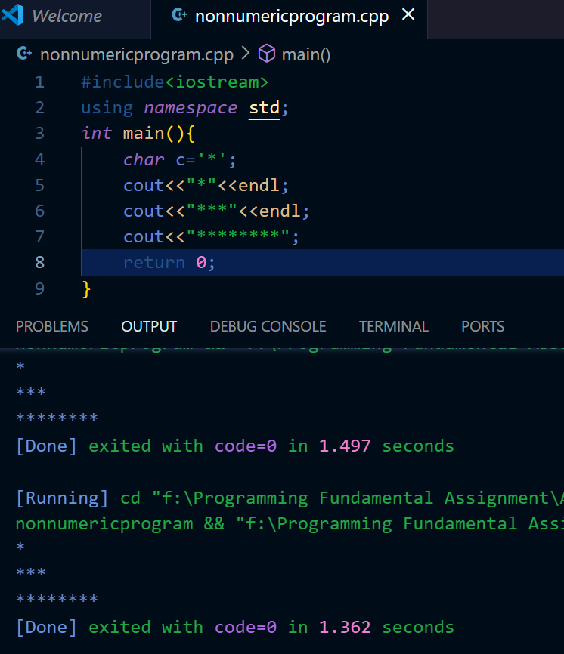

- Write a program in C++ to print star pattern using cout<<”*”; on the screen.

#include<iostream>
using namespace std;
int main(){
char c='*';
cout<<" * "<<endl;
cout<<" *** "<<endl;
cout<<" ***** "<<endl;
cout<<" ******** "<<endl;
cout<<" ************** "<<endl;
cout<<" ******************** "<<endl;
cout<<" **** **** "<<endl;
cout<<" *** *** "<<endl;
cout<<" ** ** "<<endl;
cout<<" * *"<<endl;
cout<<"*"<<endl;
return 0;
}
